Traditional Czech feast
January 17-19, 2014

Come to the original old czech pork feast with a piggy, well-built butcher and a typical Slivovice spirit.
Don’t miss this traditional event, where you’ll have the possibility to watch
a butcher’s profession, during the cooking of pork specialities.
For those, who are courageous and more experienced, there will be prepared aprons and they can become assistants of the master butcher.
You can look forward to a classic delicacies, which can not be missed at this traditional event.

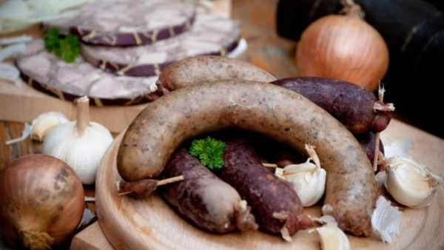
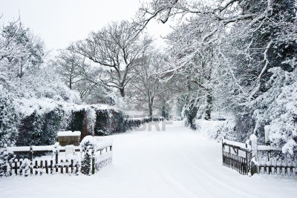
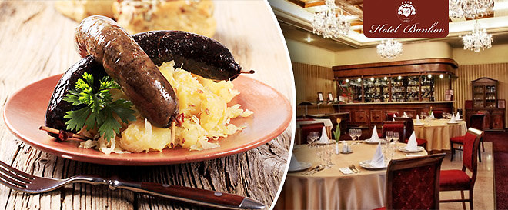

Our package includes:

Accommodation in Deluxe double Room for 2 nights ( Jan 17-19, 2014 )

Buffet Breakfast
Private use of sauna and whirlpool
Opportunity to participace on food production :
(puddings, sausage-meat, soup, brawn, etc. – tasting during the day)
Evenings Czech traditional feast in the restaurant and winery
Possibility to „ Take away „
Free Internet connection
Parking in the hotel garage

Early check-in and late check-out

VAT and all local taxes

Package price: 3.990 CZK for 2 persons for 2 nights

Special offer:
Extend your stay for special discounted rate!

For reservation please contact us on phone number +420 317 700 825
or by e-mail reservationkarlov@bellevuehotels.cz
or book online here

We are looking forward to welcoming you in hotel Bellevue Karlov in Benešov, Member of Asten Hotels

Těšíme se na Vás v hotelu Karlov v Benešově, Member of Asten Hotels

